

Wind Turbine Manufacturing and assembly process
Gamesa is one of the world’s leading manufacturers of wind turbines, and Spain’s leader in wind turbine manufacture, sales and installation. We have achieved a level of vertical integration unique in their sector, including one of the widest ranges of industrial capacity.
Gamesa designs and manufactures its own blades, root joints, and manufacturing moulds for blades and towers, in addition to performing wind turbine assembly. In addition, Gamesa has other companies that manufacture other major components of the wind turbine, such as gearboxes, generators and converters. This industrial capacity allows for the comprehensive control of the production process of the wind turbines, from their design to the manufacturing of the different components, in order to provide the greatest quality and to cut ofivery times to a minimum.

- 1. Frame assembly 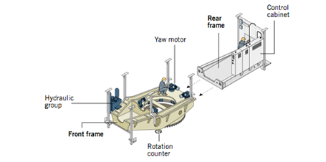
Once the yaw system is assembled with its yaw motors, column and hydraulic group and the rotational test is passed, this assembly is connected to the rear frame. Next, the rail beams and the service crane are installed, and cables are run to the control cabinet.
- 2. Gearbox assembly 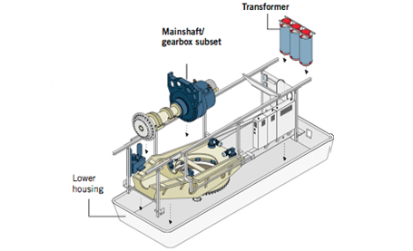
The nacelle assembly is placed within the lower housing, and the power transformer and the main shaft/gearbox subset are assembled. gearbox subset Front frame
- 3. Generator assembly 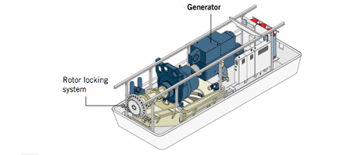
The process continues with the generator assembly and alignment and the electrical connection of all the components in the control cabinet. Once connected, the nacelle is given a comprehensive final verification check, simulating its wind farm operation.
- 4. Upper housing assembly 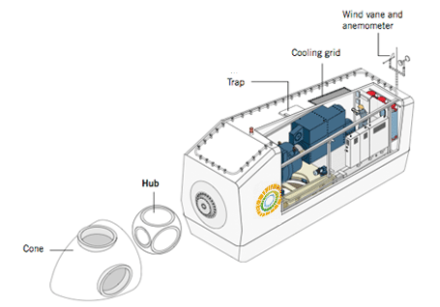
Once the nacelle verification test is passed, the upper housing is assembled and the nacelle is ready to be sent to its corresponding wind farm.

- G8X Gearbox 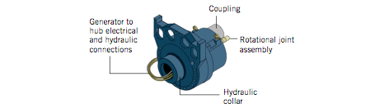
Consists of three combined stages: 1 planetary stage and two helical stages. The multiplication ratio is 1:100.5 for 50 Hz machines and 1:120.5 for 60 Hz machines.
- G8X Generator 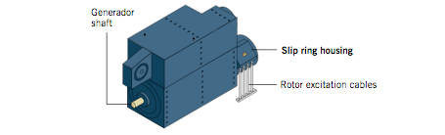
2 MW rated power electric generator. Highly efficient, it has 4 poles and is doubly-fed with a wound rotor and slip rings. The rotational speed range is from 900 to 1900 rpm, with a rated speed of 1680 rpm. The output voltage is 690 V AC.
Subir

Towers
Towers
Gamesa’s Tower Manufacturing Plants
Olazagutía (Navarra, Spain)
Cadrete (Zaragoza, Spain)
Linares (Jaén, Spain)
Fairless Hills (PA-US)
Avilés (Asturias, Spain)
Tajonar-equipment (Navarra, Spain)
Gamesa has production centers of its own for the production of wind turbines towers through the company Windar. These centers are located in Navarra, Asturias, Zaragoza and Jaén and has an equipment plant also in Navarra. On the other hand, Gamesa owns another production center in Pennsylvania (US). All these plants provide for around 37% of Gamesa's requeriments in towers. The other 63% is subcontracted to boiler shops, allowing project logistical costs to be minised
- 1. Reception and quality control of the steel plates 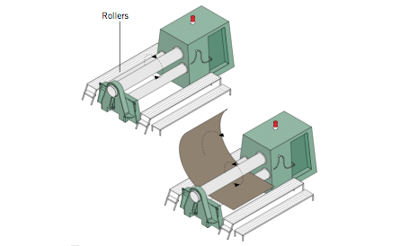
The cylinders forming the wind turbine tower are made from plated sheets that are flame cut and primed.
- 2. Shaping 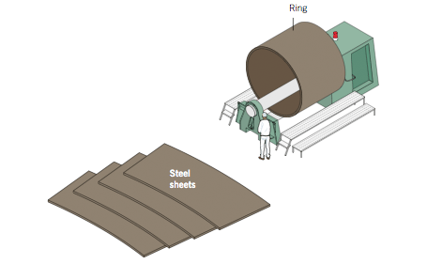
The sheets are inserted in a machine with three large rollers that shape the rings.
- 3. Welding 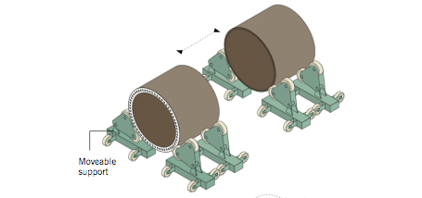
The rings are submerged arc-welded, forming sections of different lengths.
- 4. Shot peening, painting and drying 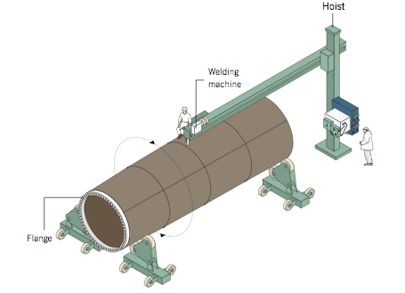
The structure is placed inside the painting and drying tunnel. Once the tower plating is finished, it is then given a surface treatment, consisting of a double-steel shot peening and three coats of paint. This provides a C-5 level protection.
- 5. Assembly of the auxiliary equipment 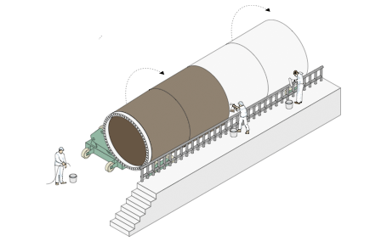
Once the tower is dry, all the service elements (such as platforms and ladders) are mounted on it.

- Sections 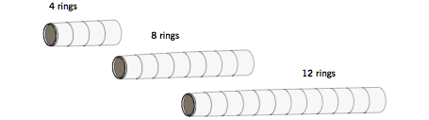
Depending on the Model and the required height (between 14 and 29 meters), each section may be made up of between 4 and 12 rings.
Altura de las torres
Range | Model | Tower
G5X | Gamesa G52-850kW | 44, 49, 55, 65 meters
G5X | Gamesa G58-850kW | 44,55, 65, 71 meters
G8X | Gamesa G80-2.0MW | 60, 67, 78, 100 meters
G8X | Gamesa G87-2.0MW | 67, 78, 100 meters
G8X | Gamesa G90-2.0MW | 67*, 78, 100 meters
Subir

Blades
Gamesa’s Blade Manufacturing Plants
Gamesa’s Blade Manufacturing Plants
Alsasua (Navarra, Spain)
As Somozas (La Coruña, Spain)
Miranda de Ebro (Burgos, Spain)
Albacete
Tuofa (Navarra, Spain)
Ebensburg (PA-US)
Tianjin (China)
The blades Gamesa uses on its wind turbines are based on its own design and manufacturing process and involve the application of the latest technology, such as the use of carbon fibre components in the Gamesa G87-2.0 MW and G90-2.0 MW Models. Gamesa has seven blade production centers that allow them to produce over 3,500 MW per year. On the other hand Gamesa owns a root joint plant in Cuenca wich has an annual production of 5,000 units per year.
- 1. Beam manufacture 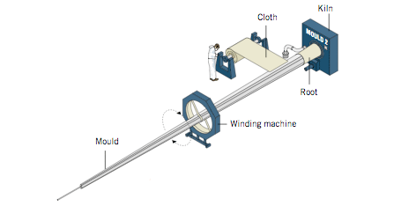
Using glass and carbon fiber materials that have been impregnated with epoxy resin as a base, several cloth lengths are cut and placed in a mould. They are then subjected to a curing process.
- 2. Shells manufacture 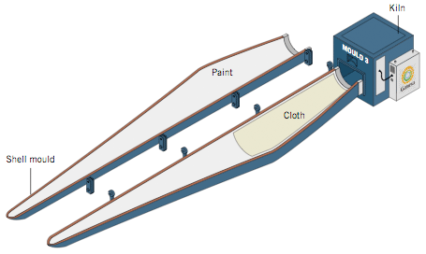
After applying a coat of paint which will act as a protective coating on the blade, glass fiber is used to manufacture the shells, following the same manufacturing process as for the beam.
- 3. Assembly 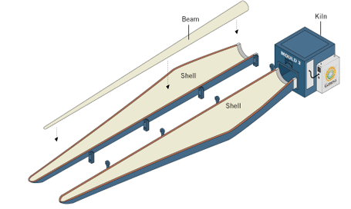
Once the two shells are finished, we proceed with their assembly and glue the beam between the two shells. 3
- 4. Curing 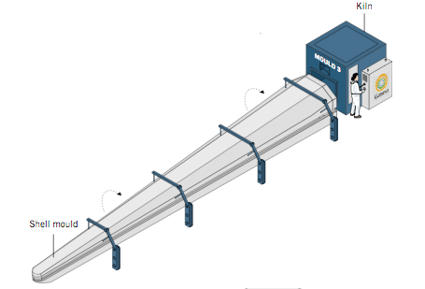
The assembly is passed through the kiln once more, forming a compact unit.
- 5. Trimming and polishing 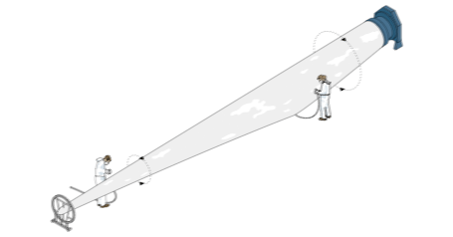
The blade assembly is removed from the mould and is transferred to the finishing area, where the leading and trailing edges of the blades are finished and subjected to a final revision.
- |
Rotor measurements
Range | Model | Rotor diameter
G5X | Gamesa G52-850kW | 52 m.
G5X | Gamesa G58-850kW | 58 m.
G8X | Gamesa G80-2.0MW | 80 m.
G8X | Gamesa G87-2.0MW | 87 m.
G8X | Gamesa G90-2.0MW | 90 m.
Subir

Assembly
Gamesa uses specialized means of transport to convey the wind turbines to their destination on the wind farm. These means of transport allow for access to any kind of terrain, including the most difficult, with a minimal impact on the environment. Once on site, an experienced team of operators carry out the installation of the turbines. Finally, Gamesa performs the start up operations and takes responsibility for the operation and maintenance of the wind turbine throughout its working life.

Construction and foundation
Before the wind turbine is transported and assembled, various tasks are performed to prepare the land, such as concrete work and constructing the assembly platform. The latter requires compaction able to support weights of around 4kg/cm2.
- 1. Tower Erection 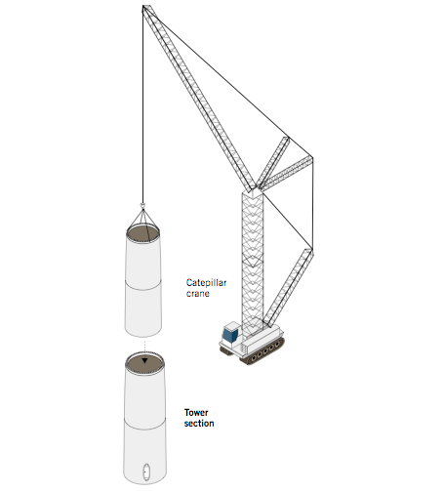
The tower sections are placed one on top of the other using lattice cranes. They may be either caterpillar or hydraulic jack types. Caterpillar-type cranes, with widths between 8.5 and 10 m., are able to change position easily. 5 m.-wide jack types are suitable for working on difficult terrain, due to their narrow width.
Once the sections are in place, the field personnel connect and assemble the parts.
The placement and height of the wind turbine are studied beforehand to guarantee maximum wind performance. Nacelle
- 2. Nacelle installation 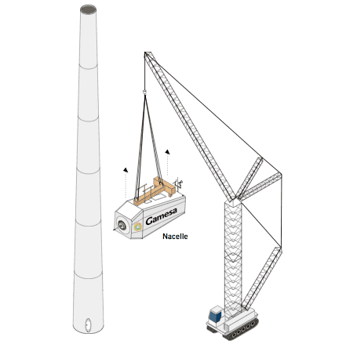
Once the tower is assembled, the next step is to install the nacelle, which is connected to the top tower section. The electrical connection is established to all components, parallel to the wind turbine assembly.
- 3. Rotor installation 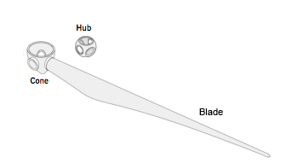
This assembly may be performed on the ground, either connecting all three blades to the hub, or by connecting them blade by blade. The second method requires less space for maneuvering and makes the assembly process quicker. Once the nacelle is installed, the hub and cone are raised, followed by the blades, which are lifted horizontally one by one.
Subir
« back to Wind turbines

Wind turbines
- Introduction
- Design and development
- Manufacture
- Catalogue
- Catalogue of Made
Wind turbine catalogue
Wind farms
Wind farm search

